## 

## 

## 

## horizontal line

**T215B: Communication and information technologies (II)**

**01/12/2021**

**─**

**Nancy Al Aswad -2180385**

Arab Open University

Jordan

# **Question ( 1 ) :**

**============**

a. Give a brief description of VPN. (4 marks)

b. Mention at least four of the aspects of design and planning of a VPN policy. (4 marks)

c. Describe at least eight benefits of a VPN? (8 marks)

d. Explain at least four limitations of a VPN?

**a. Give a brief description of VPN. (4 marks)**

The Virtual Private Network **(**[**VPN**](https://books.google.jo/books?hl=ar&lr=&id=OuFQ3t7eF4IC&oi=fnd&pg=PR9&dq=Virtual+Private+Network+(VPN)&ots=hglXxADL-x&sig=SapUfF0fPj66kIJ35PEWWhw9m-4&redir_esc=y#v=onepage&q=Virtual%20Private%20Network%20(VPN)&f=false)**)** known as the way to simulate a private network over public net- work,we called it “Virtual” for using virtual connections in it , actually it is a temporary connections without real physical presence,and with Secure virtual connections which created between two networks or between two machines, a machine and a network.

**b. Mention at least four of the aspects of design and planning of a VPN policy. (4 marks)**

# **What Are Effective VPN Policies?**

[And to create](https://translate.google.com/?hl=en&tab=TT&sl=en&tl=ar&text=%0A%20b.%20Mention%20at%20least%20four%20of%20the%20aspects%20of%20design%20and%20planning%20of%20a%20VPN%20policy.%20(4%20marks)%0A%0AWhat%20Are%20Effective%20VPN%20Policies%3F%20%0A%0A%0AAnd%20to%20create%20and%20%20design%20%20Effective%20VPN%20policies%20we%20should%20clearly%20define%20security%20restrictions%20imposed%20on%20VPNS%20and%20align%20with%20the%20overall%20IT%20mission%20and%20goals%20of%20your%20organization%20%2C%20Also%20VPN%20policies%20should%20take%20the%20%20risk%20consideration%20to%20ensure%20the%20confidentiality%20and%20stability%20of%20your%20organization%27s%20infrastructur%0A%0A%20Like%20all%20security%20policies%2C%20your%20VPN%20policy%20should%20start%20with%20a%20thorough%20risk%20assessment%20and%20analysis.%20Without%20fully%20understanding%20the%20assets%2C%20processes%2C%20threats%2C%20and%20risks%20of%20VPNS%2C%20you%20cannot%20effectively%20use%20or%20manage%20the%20device%20or%20traffic.%20Developing%20your%20VPN%20security%20policy%20is%20not%20a%20simple%20or%20straightforward%20task.%20You%20need%20to%20plan%20for%20time%20and%20effort%20to%20address%20a%20wide%20variety%20of%20issues%20and%20concerns.%20Some%20of%20the%20aspects%20of%20design%20and%20planning%20of%20a%20VPN%20policy%20include%20(but%20are%20not%20limited%20to)%3A%20%E2%80%A2%20Considering%20the%20benefits%20and%20drawbacks%20of%20software%20and%20hardware%20VPN%20solutions%20%E2%80%A2%20Imposing%20stringent%20multifactor%20authentication%20(multiple%20elements%20you%20know%20or%20that%20vali-%20date%20who%20you%20are)%20on%20all%20VPN%20connections%20%E2%80%A2%20Implementing%20strong%20access%20control%20(authorization)%20restrictions%20on%20all%20VPN%20connections%20%E2%80%A2%20Defining%20how%20the%20VPN%20will%20be%20managed%2C%20through%20what%20interfaces%2C%20and%20by%20whom%20Exploring%20the%20complexities%20of%20patch%20management%20over%20VPN%20%E2%80%A2%20Defining%20the%20mechanisms%20of%20providing%20remote%20technical%20support%20for%20VPN%20telecommuters%20&op=translate) and design Effective VPN policies we should clearly define security restrictions imposed on VPNS and align with the overall IT mission and goals of your organization , Also VPN policies should take the risk consideration to ensure the confidentiality and stability of your organization's infrastructure.

# **Effective VPN policies are those that clearly define security restrictions imposed on VPNS and align with the overall IT mission and goals of your organization. VPNS can offer numer- ous exciting possibilities for mobility and interconnection. However, VPNS can also be a risk to the confidentiality and stability of your organization's infrastructure. Like all security policies, your VPN policy should start with a thorough risk assessment and analysis. Without fully understanding the assets, processes, threats, and risks of VPNS, you cannot effectively use or manage the device or traffic. Developing your VPN security policy is not a simple or straightforward task. You need to plan for time and effort to address a wide variety of issues and concerns.**

# **Some of the aspects of design and planning of a VPN policy include (but are not limited to):**

# **• Considering the benefits and drawbacks of software and hardware VPN solutions**

# **• Imposing stringent multifactor authentication (multiple elements you know or that vali- date who you are) on all VPN connections**

# **• Implementing strong access control (authorization) restrictions on all VPN connections • Defining how the VPN will be managed, through what interfaces, and by whom Exploring the complexities of patch management over VPN**

# **• Defining the mechanisms of providing remote technical support for VPN telecommuters**

**c. Describe at least eight benefits of a VPN? (8 marks)**

**d. Explain at least four limitations of a VPN?**

# **If you understand these limltations and address ea strophic mistakes when correctly Installing and productively using VPNS.**

# **One of the primary tools to accomplish this Is the VPN policy.**

# **Question ( 2 ) :**

**============  
1 ) . The readable Original PlainText is p ≡ c + 𝐾’mod 26**

**2 ) . Table with details required**

| **Cipher text** | **O** | **G** | **T** | **J** | **Q** | **P** | **P** | **B** |
| --- | --- | --- | --- | --- | --- | --- | --- | --- |
| **Number Equivalent** | **14** | **6** | **19** | **9** | **16** | **15** | **15** | **1** |
| **Key** | **o** | **p** | **t** | **i** | **c** | **a** | **l** | **o** |
| **Number key equivalent** | **14** | **15** | **19** | **8** | **2** | **0** | **11** | **14** |
| **Number k’ equivalent**  **K’ = 26 - k** | **12** | **11** | **7** | **18** | **24** | **26** | **15** | **12** |
| **Plain Number**  **p ≡ c + 𝐾’mod 26** | **0** | **17** | **0** | **1** | **14** | **15** | **4** | **13** |
| **Plain text** | **a** | **r** | **a** | **b** | **o** | **p** | **e** | **n** |

**Question ( 3 ) :**

**============**

**a ) . The given data :**

**====================**

**Similarity value = less than 5% in strictly differences**

**Table shows differences of minutiae pairs for FP1, FP2 and FP3**

**We got 15 minutiae pairs**

**. The Answer :**

**===============**

**For FP1,out of 15 we can take (10 ) pairs for similarity less than 5%, so we can say :**

**The FP1: Similarity = (10/15) x 100 = 66.67%**

**For FP2,out of 15 we can take (5 ) pairs for similarity less than 5%, so we can say :**

**The FP2: Similarity = (5/15) x 100 = 33.33%**

**For FP3,out of 15 we can take (9 ) pairs for similarity less than 5%, so we can say :**

**The FP3: Similarity = (9/15) x 100 = 60 %**

**b ) Now, since the threshold is 65% , we need a similarity index of at least 61% for a match , So FP1 is a match.**

**But since FP2 and FP3 have similarity percentage less than 61% , Sothey are not in match.**

**c ) The three reasons for non match can be :-**

**==================================**

1. **When a threshold is set too high, biometric data from the same person can appear not to match because of slight variations.**
2. **Dust on fingers can cause a false non match.**
3. **Hands can be too sweaty or too dry .**
4. **Surface of skin; scars , cuts or any other skin conditions.**

# **Study References :**

**==============**

1. .

<https://books.google.jo/books?hl=ar&lr=&id=OuFQ3t7eF4IC&oi=fnd&pg=PR9&dq=Virtual+Private+Network+(VPN)&ots=hglXxADL-x&sig=SapUfF0fPj66kIJ35PEWWhw9m-4&redir_esc=y#v=onepage&q=Virtual%20Private%20Network%20(VPN)&f=false>

https://books.google.jo/books?id=JVcBEAAAQBAJ&pg=PA263&dq=aspects+of+design+and+planning+of+a+VPN+policy&hl=ar&sa=X&ved=2ahUKEwiYtoLum7v0AhWO_7sIHUU6Db4Q6AF6BAgKEAI#v=onepage&q=aspects%20of%20design%20and%20planning%20of%20a%20VPN%20policy&f=false

-

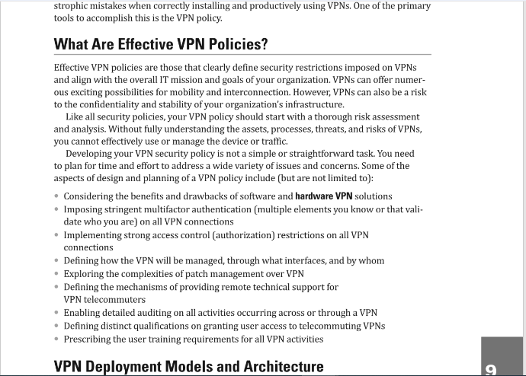

The **What Are Effective VPN Policies? reference**

https://books.google.jo/books?id=JVcBEAAAQBAJ&pg=PA263&dq=aspects+of+design+and+planning+of+a+VPN+policy&hl=ar&sa=X&ved=2ahUKEwjghb_Mn7v0AhU9g_0HHW8jBBYQ6AF6BAgIEAI#v=onepage&q&f=false